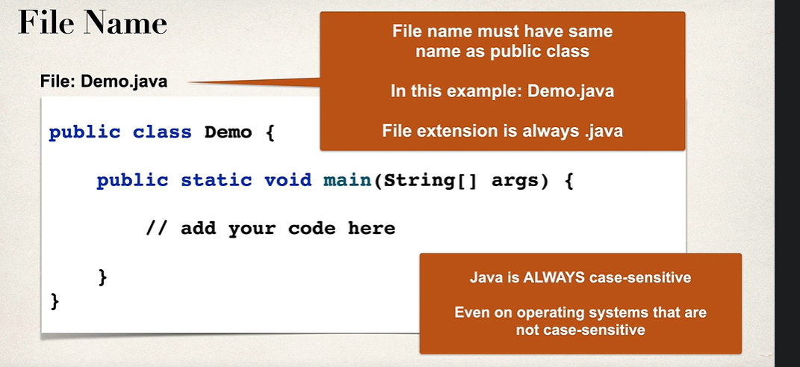

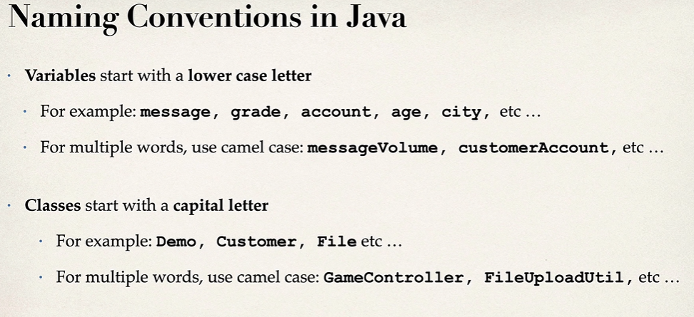

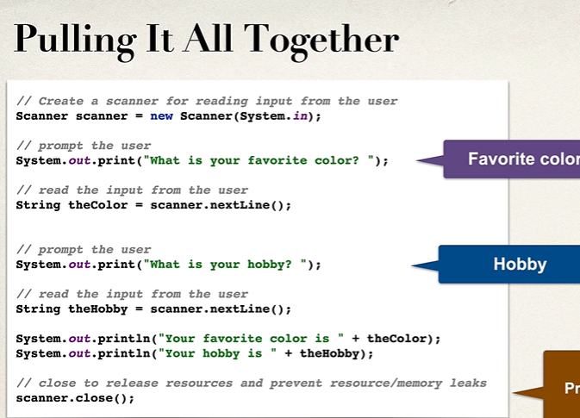

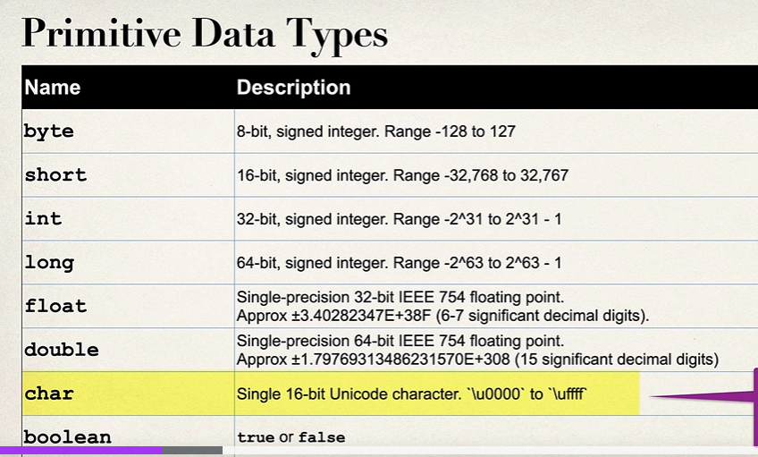

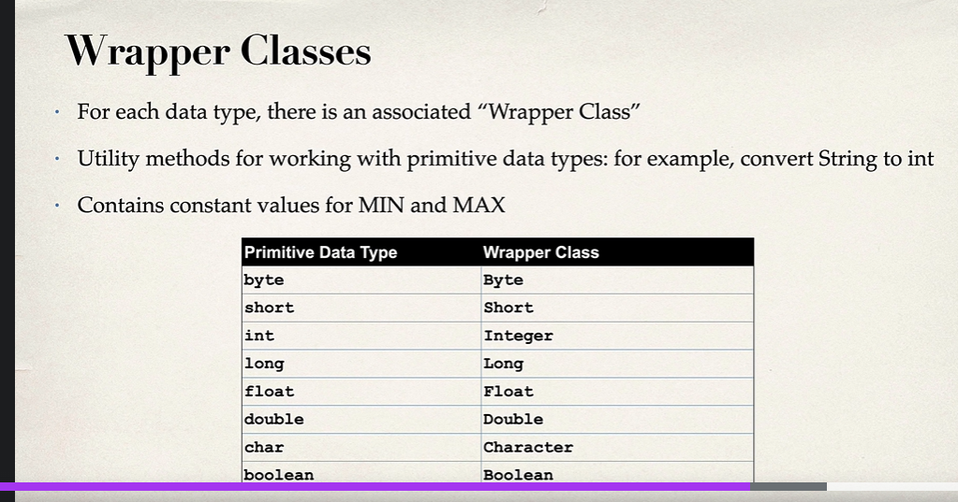

**Methods/Functions:**

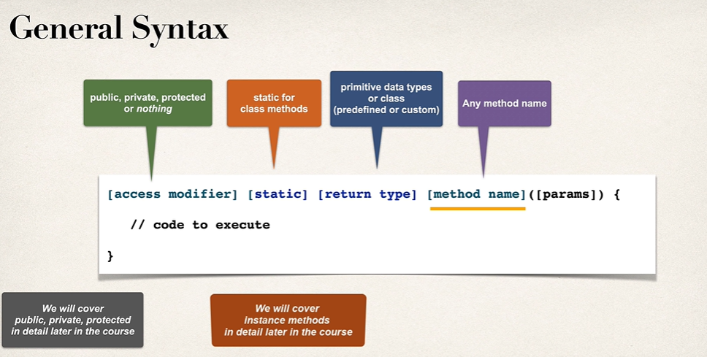

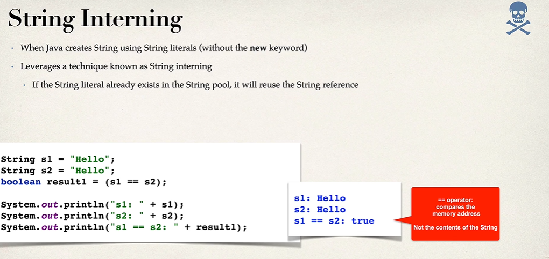

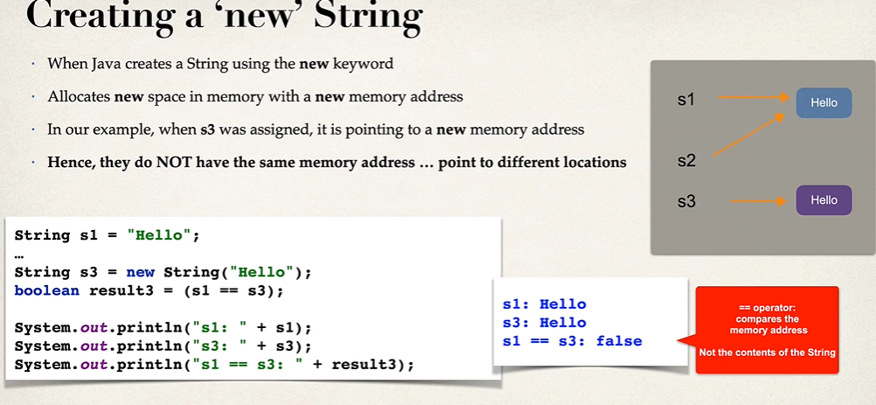

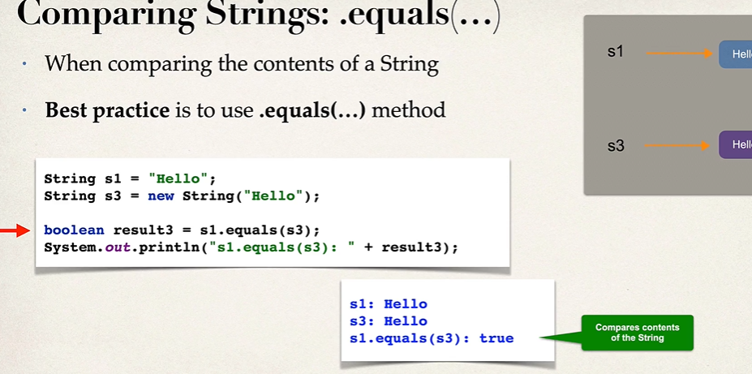

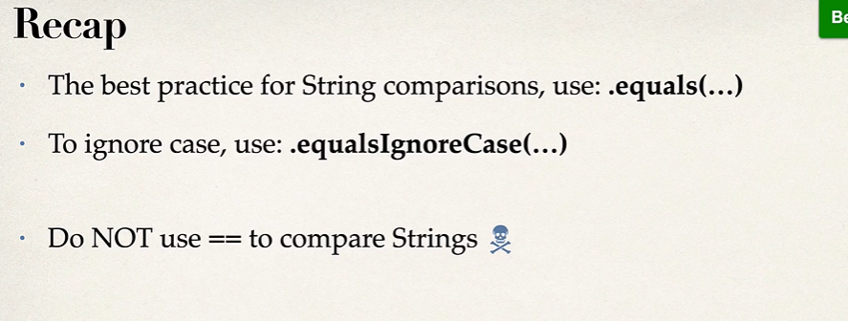

In Java, **packages** are a way to group related classes and interfaces together. They help organize your code into logical, reusable units and avoid name conflicts. Packages also provide controlled access to classes and methods through visibility modifiers.

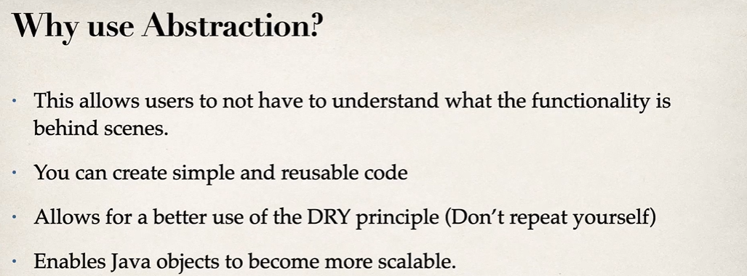

**Focus on Behavior**: It defines what operations an object can perform without exposing the actual code behind those operations

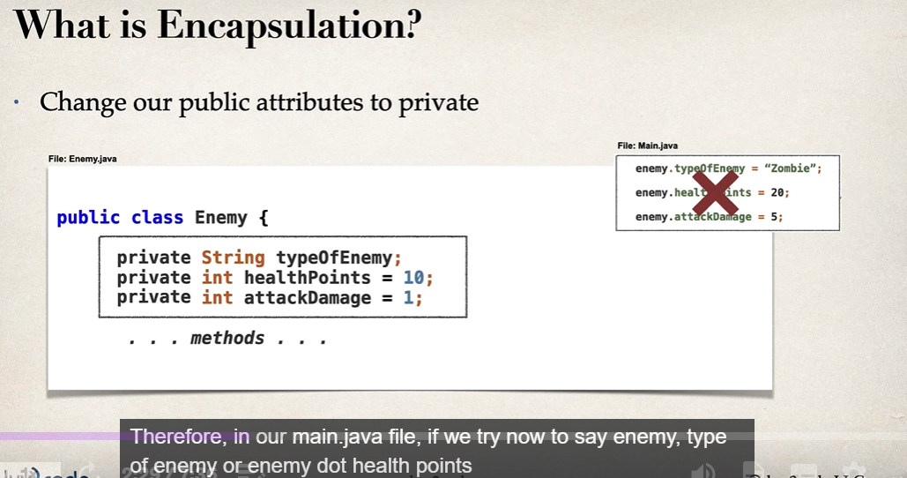

Getters and setters.

Get: get the private variables values.

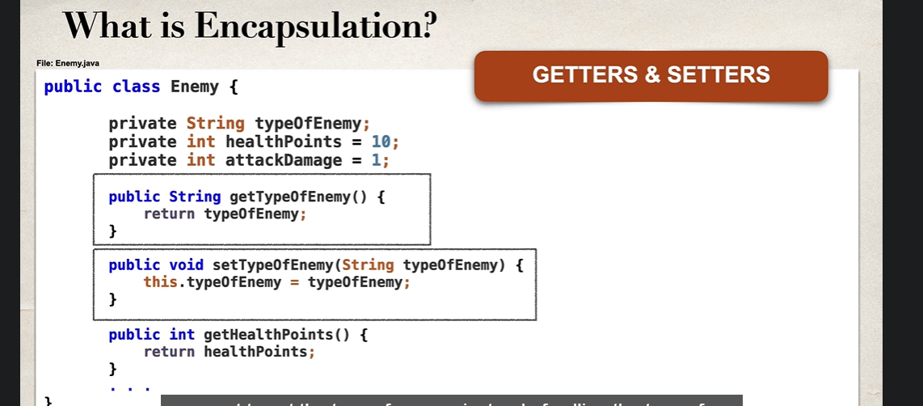

Encapsulation- bundling of data and its methods together. External files cant change the property of objects.

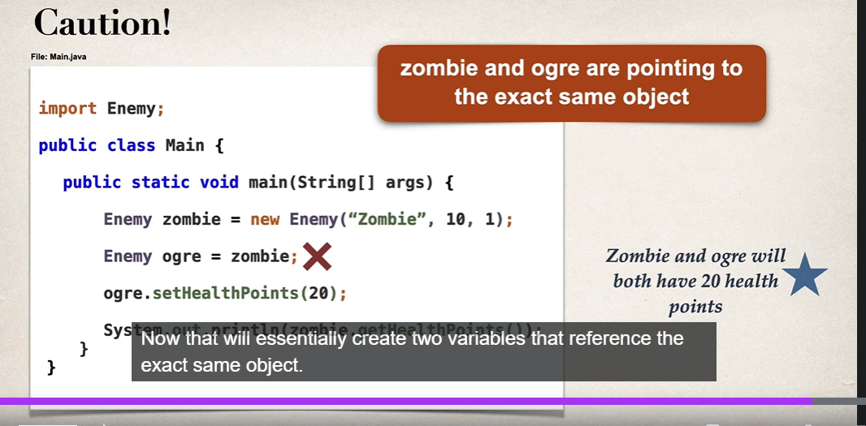

What is a POJO?

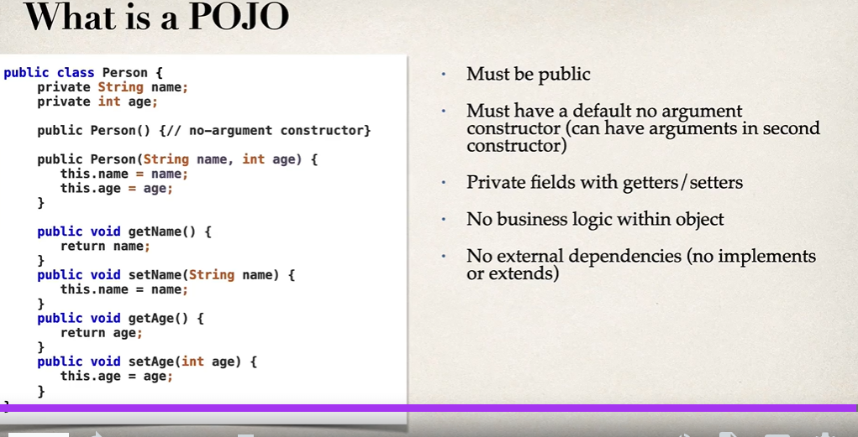

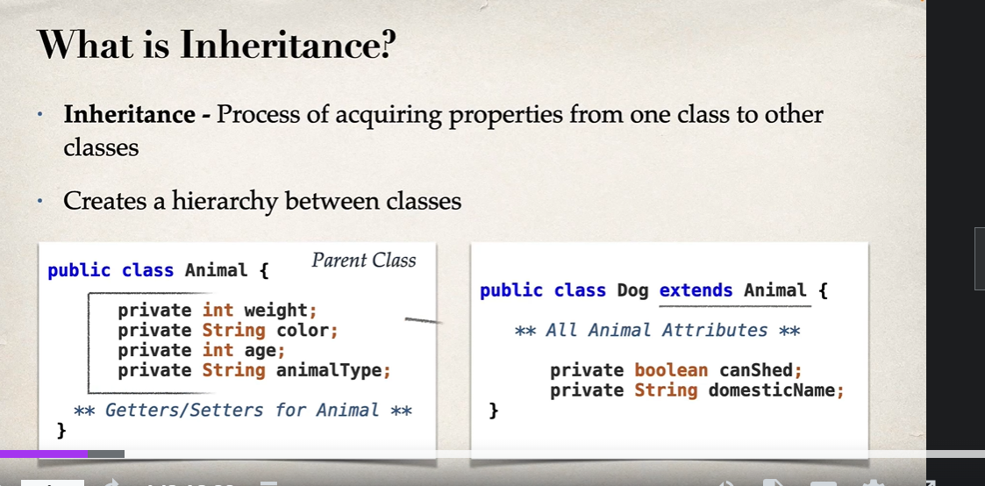

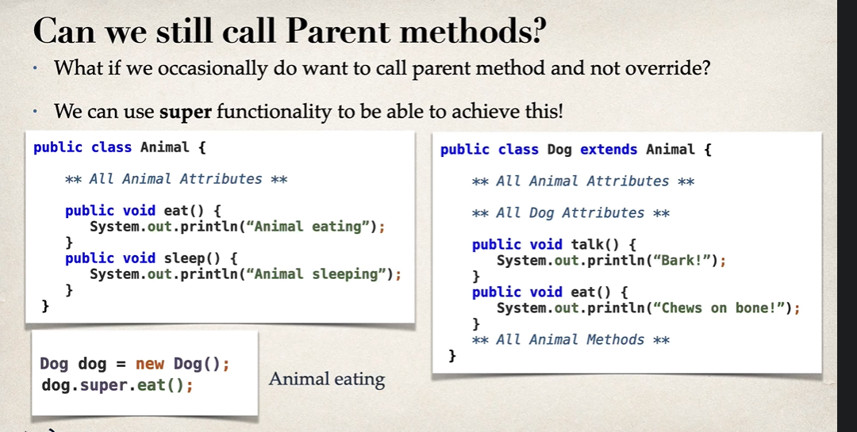

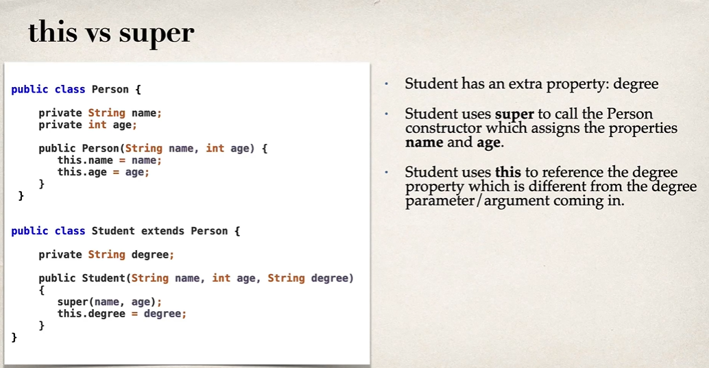

In Java, **static variables** are variables that belong to the class rather than to any specific instance of the class. They are shared among all instances (objects) of the class, meaning that all objects of the class will have the same value for the static variable.

**Polymorphism**

In object-oriented programming, polymorphism is when objects of different types can be treated as objects of a common superclass. This allows for code reusability and flexibility. For example, a function that operates on a dog-type object can also operate on objects that belong to any of the dog's subtypes.

**Interface**

Interface is a blue print of what we want our class to do.

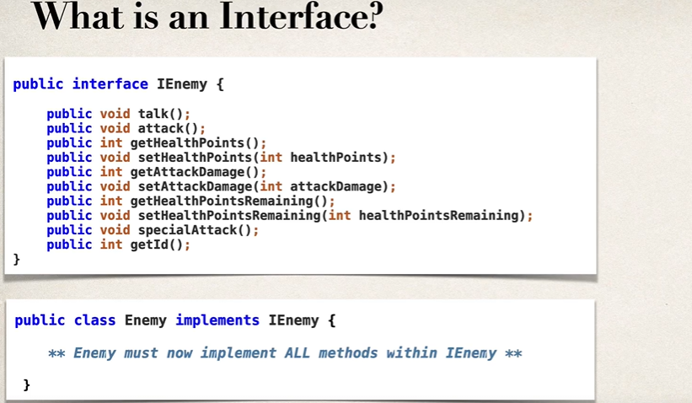

Interfaces do not include constructors because they cannot be used to create objects. However, interfaces can contain static, public, and final variables.

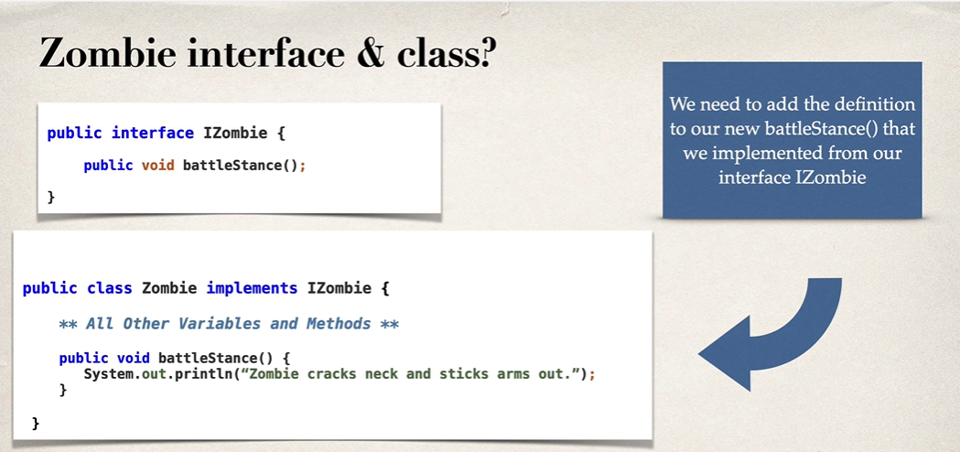

**COMPOSITION**

Creating objects of other class inside one class.

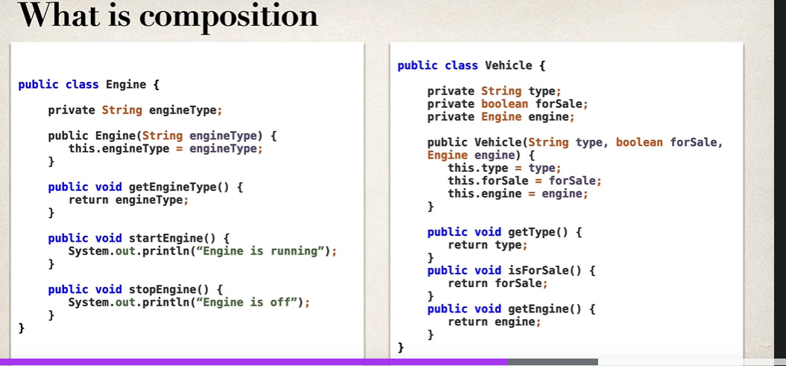

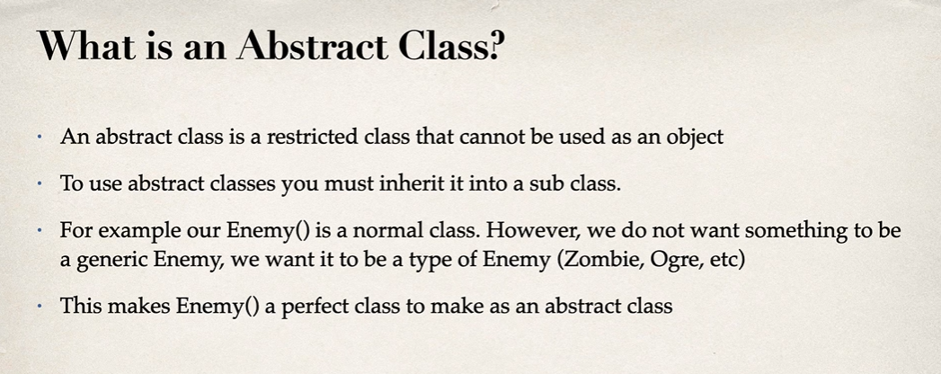

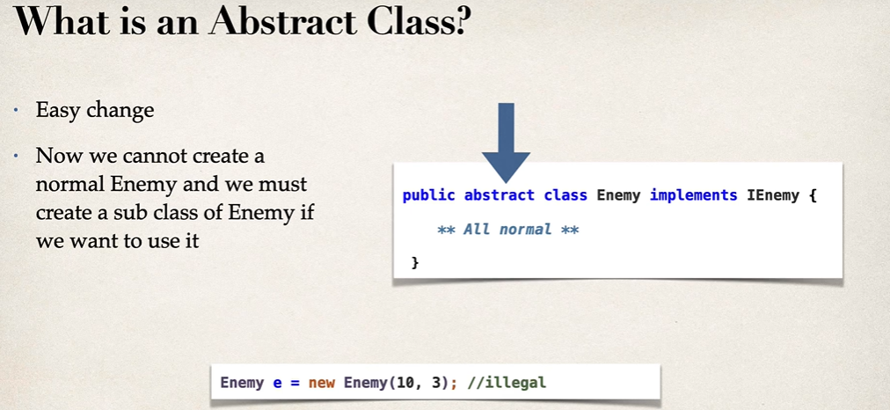

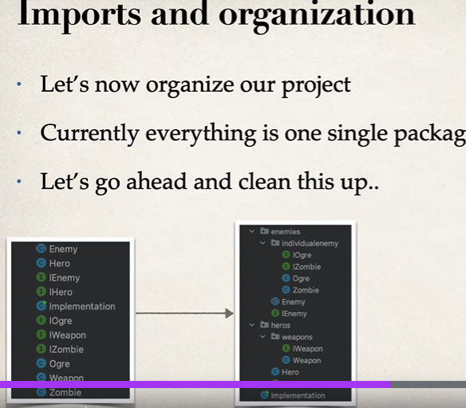

**JAVA FRAMEWORK INTERFACES**

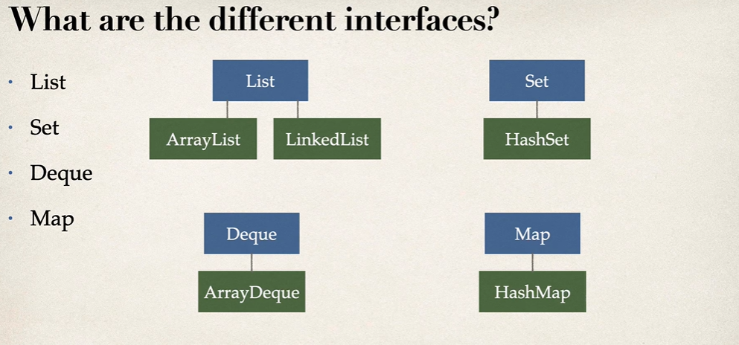

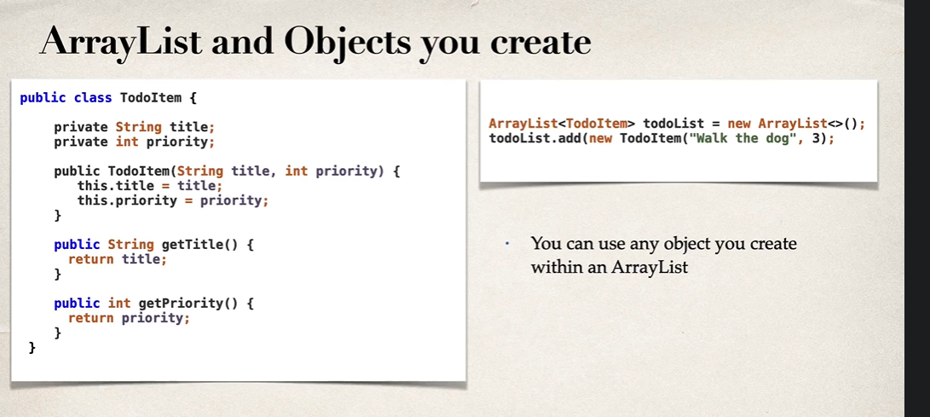

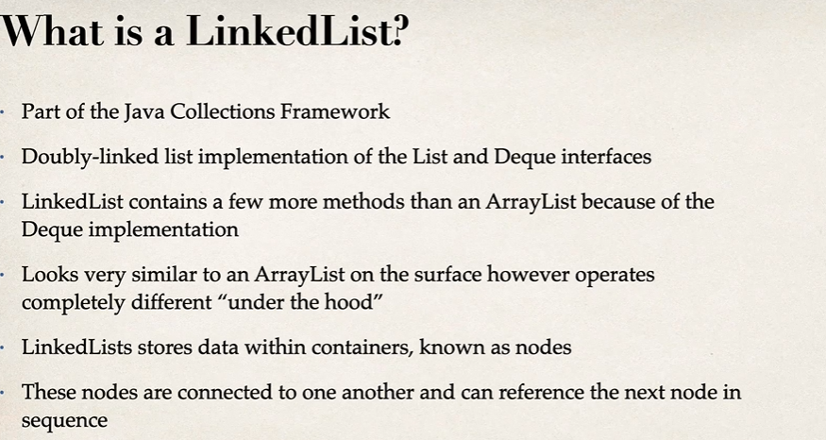

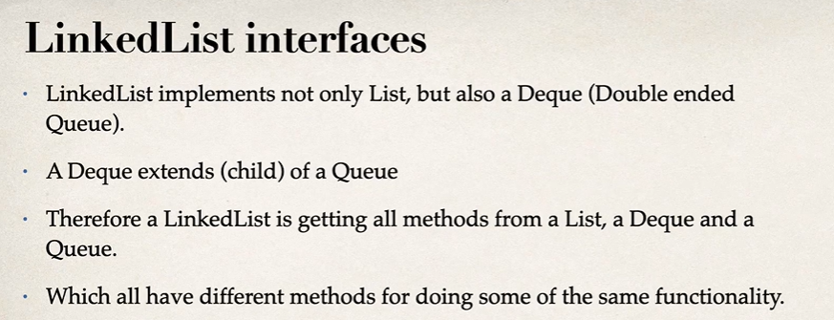

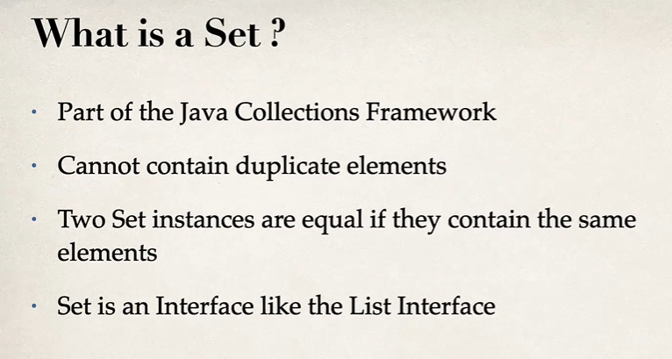 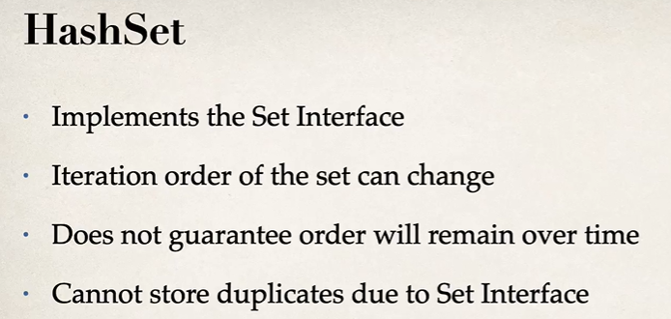

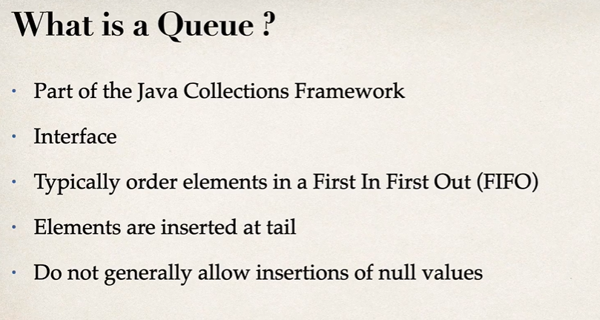

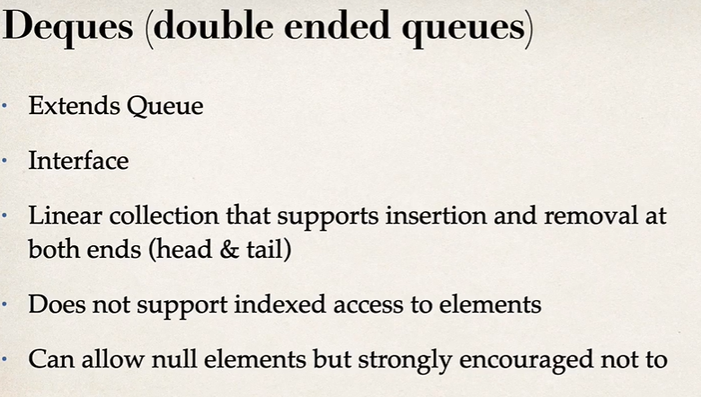

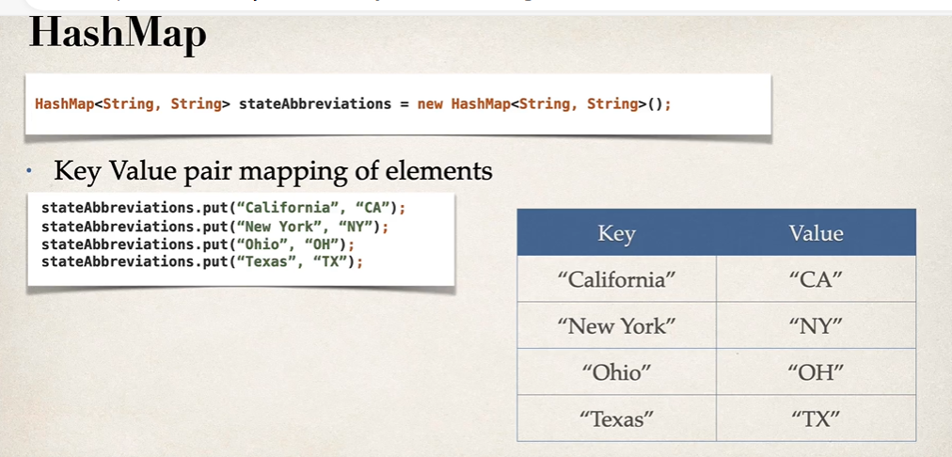

**FILES:**

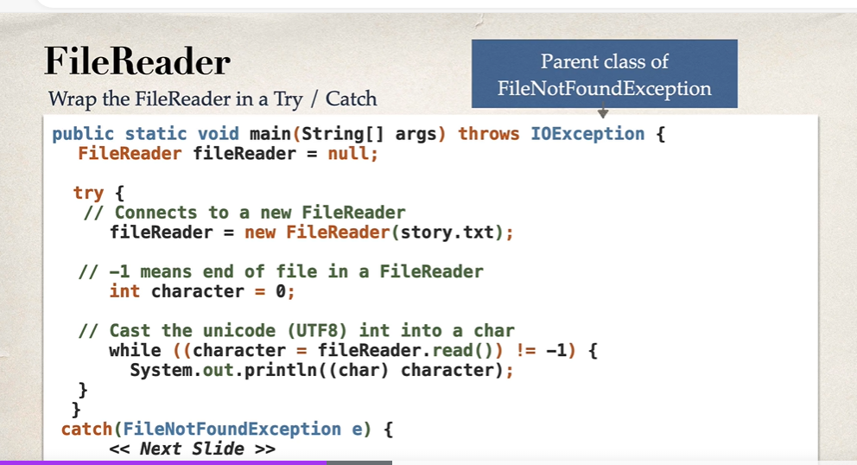

Every character in a file is in UTF 8 format. .read reads that character in utf8 and checks its not equal to -1.(-1 means it’s the end of file). If it Is not -1 cast it into a char.

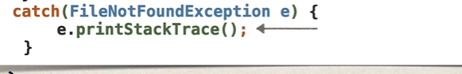

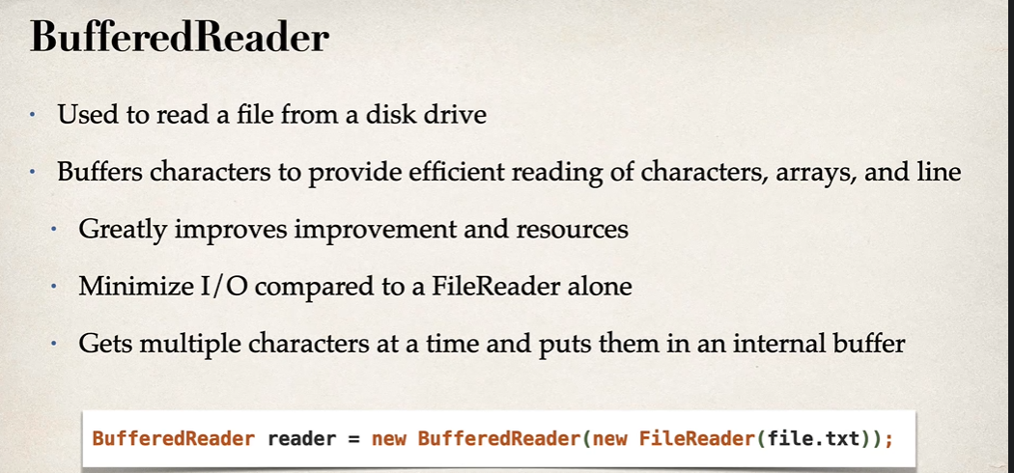

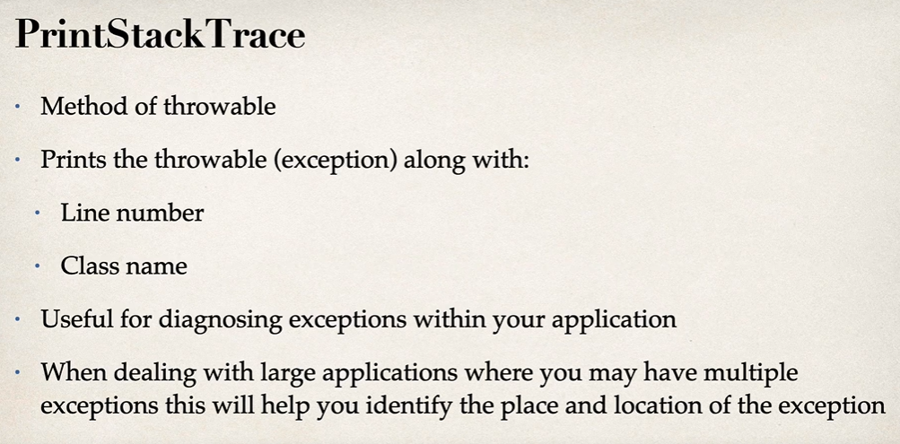

**LAMBDAS**

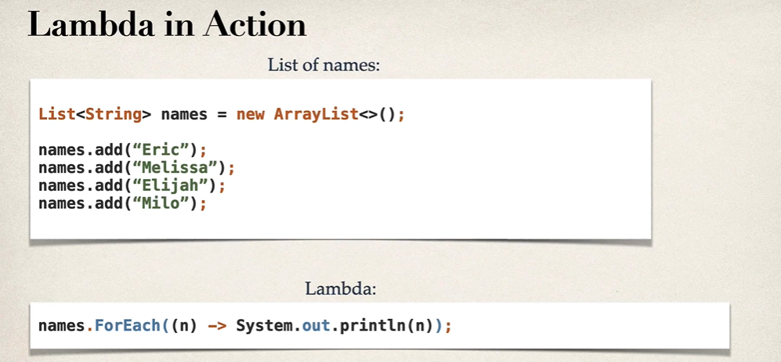

**(parameters) ->expression**

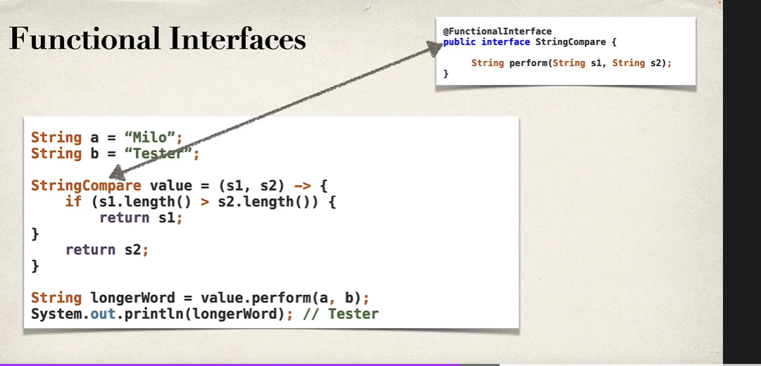

Functional interface is an interface containing only one method.

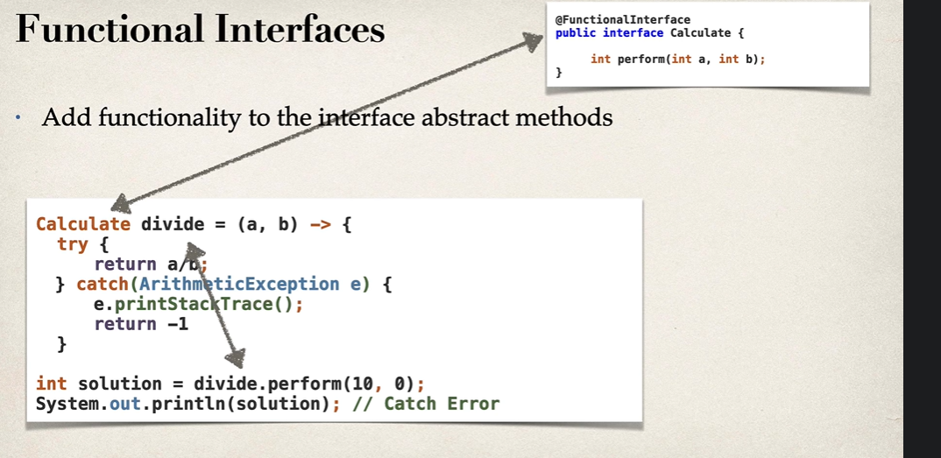

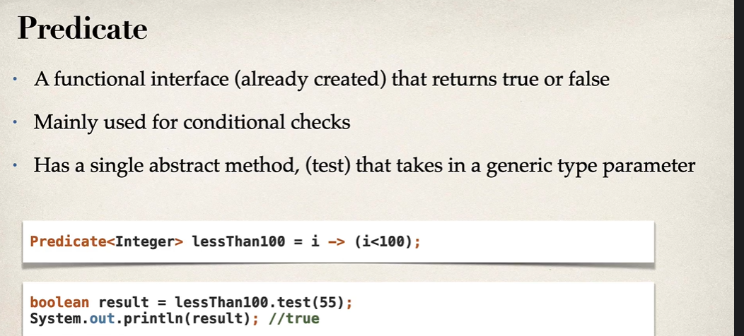

**WHAT IS A STREAM?**

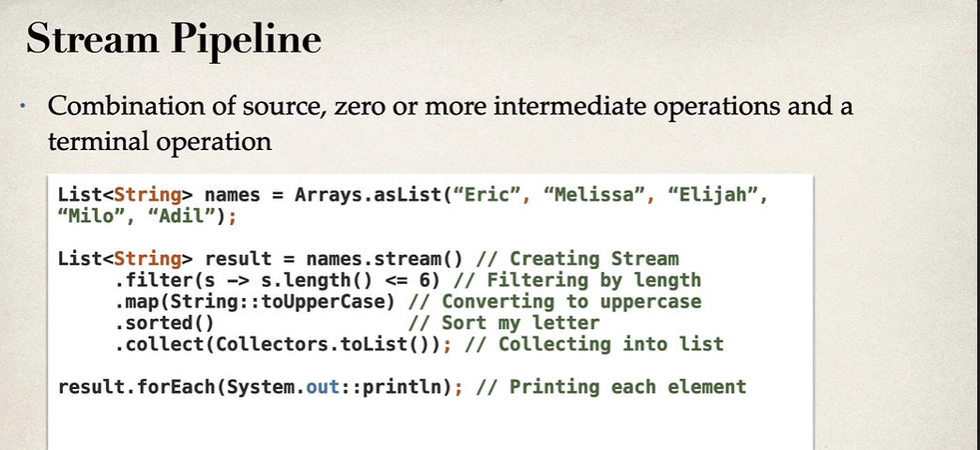

1. Declarative Style: Allows defining "what to do" instead of "how to do."
2. Pipeline Operations: Supports operations like filtering, mapping, and reducing in a chained manner.
3. Parallelism: Can process data in parallel using parallelStream().

**Stream Operations**

**Intermediate Operations (return a new stream):**

* filter(): Filters elements based on a condition.
* map(): Transforms elements.
* sorted(): Sorts elements.

**Terminal Operations (consume the stream):**

* collect(): Collects elements into a collection.
* forEach(): Iterates over elements.
* reduce(): Reduces elements to a single result.

